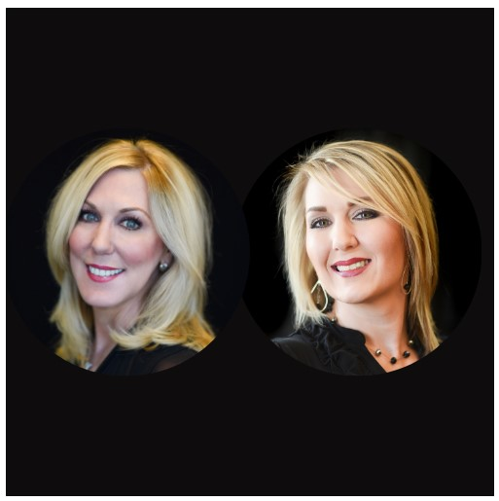
Carla & Brandi
Carla Singleton
Founder & Managing Partner | Azure Properties
Licensed Realtor | Panama City Beach, FL
Carla Singleton is a dynamic entrepreneur and licensed real estate professional with over 20 years of business ownership experience and a background in Information Technology. She is the founder and managing partner of Azure Properties, a boutique property management firm specializing in short-term vacation rentals along the Emerald Coast of Panama City Beach.
Under Carla’s leadership, Azure has grown into a highly regarded company known for delivering exceptional guest experiences, maximizing owner revenue, and maintaining full compliance with state and local lodging tax, and fire/safety requirements.
Her expertise spans property marketing, guest services, dynamic pricing strategies, and operational efficiency, with a strong emphasis on digital advertising, SEO, and one-line reputation management.
As a hands-on leader, Carla works closely with her daughter and business partner, Brandi Bolin, who shares her values and strategic vision. Together, they provide a seamless, family-managed experience that blends professionalism with genuine hospitality — making both owners and guests feel like part of the family.
Carla is known for her resilience, integrity, and people-first mindset — qualities that have helped her navigate business growth, real estate sales, and major life transitions with strength and grace. Whether managing beachfront condos, guiding property owners, or mentoring her team, Carla brings experience, empathy, and excellence to every facet of her work.

Brandi Bolin
Manager & Co-Owner | Azure Properties
Vacation Rental Specialist | Panama City Beach, FL
Brandi Bolin is the friendly, go-to person at Azure Properties — the one who knows exactly what it takes to keep every beach vacation running smoothly. As co-owner and day-to-day operations manager, she makes sure guests feel welcome, owners feel confident, and every rental feels like home.
Brandi works alongside her mother and mentor, Carla Singleton, to deliver exceptional property management services along the PCB Gulf Coast. With years of hands-on experience and a passion for hospitality, Brandi keeps things running smoothly while making it all look easy.
Brandi’s expertise includes guest communication, reservation management, owner relations, and on-the-ground property coordination. She plays a key role in implementing efficient systems and ensuring that every aspect of the guest experience — from first inquiry to check-out — runs smoothly. Known for her quick response time, friendly professionalism, and strong problem-solving skills, Brandi is a trusted point of contact for guests, owners, and team members alike.
In addition to managing daily operations, Brandi supports marketing initiatives, assists with tax and Fire Marshall compliance, and helps oversee contractor coordination and property readiness — all with an eye toward consistency and quality. Her deep knowledge of Azure’s processes, paired with her commitment to excellence, reflects the company’s high standards and personal touch.
Brandi is proud to be part of a family-managed business rooted in integrity, innovation, and coastal hospitality.

