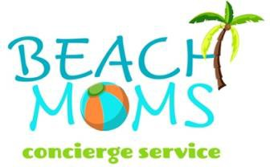

# THE ULTIMATE HASSLE-FREE VACATION

Concierge Services in Gulf Shores, Orange Beach and Fort Morgan, Alabama and Perdido Key, Florida

When you go on vacation, the goal is to unwind—not to navigate unfamiliar grocery stores or spend hours on the phone booking attractions, fishing charters, dinner reservations, and beach gear! This year, focus on soaking up the sun and enjoying the sand while we take care of the vacation “chores.”

We’ve teamed up with The Beach Moms Concierge Services to ensure you have the ultimate hassle-free experience. As the top concierge service on the Alabama Gulf Coast, The Beach Moms can add the finishing touches to your getaway in Gulf Shores, Orange Beach, Fort Morgan, and Perdido Key.

Choose from a variety of packages, each offering a range of services tailored to your needs.

Please note that these packages are separate from your vacation reservation and must be arranged directly through The Beach Moms. The costs of items and excursions are not included in the packages.

Review the [Terms of Service](https://go.thryv.com/v/beachmoms/files/4wbolkmsjmqjptkb/download) prior to placing an order.

Call Your Beach Mom: 251-279-8400 Email: [Info@TheBeachMoms.net](mailto:Info@TheBeachMoms.net)

# EASY BREEZY

Grocery/Non-Alcoholic Beverage, Pickup, Delivery and put away before arrival.

* [Families of 1-8: $175](https://go.thryv.com/site/beachmoms/online-scheduling?service=tneva80rcc2titd5)
* [Families of 9-15: $320](https://go.thryv.com/site/beachmoms/make-payment?action=3ah778fn6966b91q)
* [Families of 16 –](https://go.thryv.com/site/beachmoms/make-payment?action=hbyjtlk824sdn999) 20: $425

# SANDY BEACH

Easy Breezy package, plus beach chair/umbrella reservations, beach toy purchase or rentals, and dinner reservations.

* [Families of 1-8: $220](https://go.thryv.com/site/beachmoms/make-payment?action=0q6ohml5c25sd486)
* [Families of 9-15: $400](https://go.thryv.com/site/beachmoms/make-payment?action=219jf4dn5jnfuj5z)

* [Families of 16-20: $525](https://go.thryv.com/site/beachmoms/make-payment?action=enta5f5gjmpr8i6u)

# SALTY AIR

Easy Breezy, Sandy Beach plus private chef menu planning and booking and transportation arrangement.

* [Families of 1-8: $250](https://go.thryv.com/site/beachmoms/make-payment?action=emf07tu9qw74fhq1)
* [Families of 9-15: $450](https://go.thryv.com/site/beachmoms/make-payment?action=axzf20qmwxun7u47)
* [Families of 16-20: $600](https://go.thryv.com/site/beachmoms/make-payment?action=zlvw3bvtv4cv3bkt)

# PALM TREE

All of the above packages plus booking two excursions (excludes the excursion cost). Note: An excursion can be for one person or the whole family.

* [Families of 1-8: $320](https://go.thryv.com/site/beachmoms/make-payment?action=mxivf132r8ips2we)
* [Families of 9-15: $525](https://go.thryv.com/site/beachmoms/make-payment?action=zjlqd0z73sexrmqn)
* [Families of 16-20: $700](https://go.thryv.com/site/beachmoms/make-payment?action=u0y1chxs7q1oez56)

Each additional excursion booking is $35. Excludes actual activity cost.

# HIGH TIDE

All of the above, plus arranging a photographer for your family photoshoot.

* [Families of 1-8: $420](https://go.thryv.com/site/beachmoms/make-payment?action=l4zxq8puv3k0mw1b)
* [Families of 9-15: $675](https://go.thryv.com/site/beachmoms/make-payment?action=grf1iw9bb19ho0wd)
* [Families of 16-20: $900](https://go.thryv.com/site/beachmoms/make-payment?action=etdnhbz7age0sgpq)

# ALA CARTE

Gift Basket design and delivery, decorating, private chef planning, etc.

* [Custom Quote](https://www.thebeachmoms.net/contact)

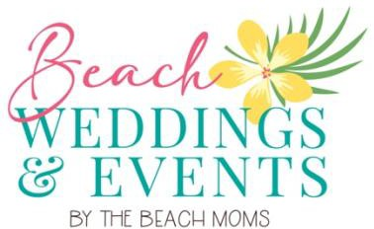

# EVENT PLANNING

The Beach Moms would be delighted to assist you in planning family reunions, bachelor and bachelorette parties, holiday gatherings, corporate retreats, and other group events, including personalized weddings. Please [contact us](https://www.thebeachmoms.net/special-occasions) for custom pricing.

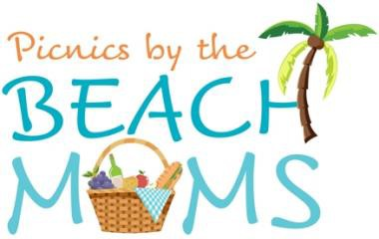

# PICNICS BY THE BEACH MOMS

# Whether you’re celebrating a birthday, bachelorette party, or planning to pop the question, a beach picnic is the perfect way to mark the occasion! The Beach Moms can host custom-curated picnics for groups of 2 to 32 in Gulf Shores, Orange Beach, Fort Morgan, or Perdido Key, FL.

# Each picnic lasts two hours and includes:

# Eco-friendly cutlery, napkins, plates, and cups

# Comfortable, plush seating with pillows

# Extra pillows and blankets for cooler days

# Bluetooth speaker for your music

# Ice bucket filled with sparkling water

# Umbrella or tent for sun protection

# Additional options are available, including catered charcuterie, photography services, cornhole, beach sling chairs, giant Jenga, fresh flowers, customized materials, and napkin colors. For custom pricing and to check date availability. [Contact us](https://www.thebeachmoms.net/beachpicnics) for custom pricing and date availability at 251-609-2114.