Other details
Internet Access
We offer complimentary WiFi throughout the condo:
Network Name: MauiZ3
Password: mauibeachfun

Telephone
Local phone calls are free of charge. For long distance, please use a calling card.
The condo phone number is: (808) 868−4985

Electricity
110 V – 60 Hz

Air Conditioning instructions:
Since electricity is extremely expensive on the island, we kindly ask our guests to help us conserve energy.
We have fans in each room that do a great job cooling on their own. To turn fans on high, move the knob up to the first position above off (not all the way up as you would expect). All the way up, is actually low.
Please make sure that windows and doors are shut when operating air conditioners and try not to set thermostat below 70 degrees. As a courtesy to our guests, we have not installed timers on our air conditioners, as we know how annoying it is to get up in the middle of the night to reset the timers so please make sure that AC is turned off when you are not in the condo.
Our air conditioners have an economy mode that helps reduce the costs but will cause the unit to turn on and off frequently. This can be bothersome to some guests so if you are experiencing this, feel free to turn economy mode off.

Washer and Dryer:
I am sure many of you already know how to use a washer and dryer. However, we recently traveled to Italy and for the life of us, we could not figure out how to use the machine. We are including instructions for our international guests.
To use the washing machine, put half a capful to one capful (depending on size of load) in washing machine along with your clothes. If washing the condo’s linens, please wash whites separately from any colored fabric.
On the first knob, select appropriate setting for the type of clothes being washed. Set temperature and size of load and then close the lid of washer.
TV Remote:
To use the TV, both the cable box and TV need to be turned on. See picture below:
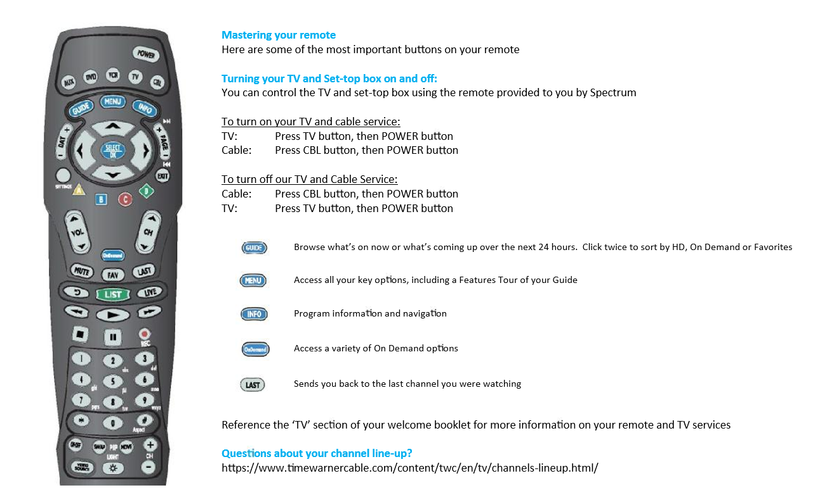
If you have both TV and cable box on and the TV says no signal or has a blank screen you may need to change the source-Hit TV button at top and toggle between sources using the Video source button on the bottom left side until you see a picture.

Beach equipment:
Did you see the beach equipment we provide? It can be found in the closet in the bedroom. Feel free to enjoy the equipment during our stay but please rinse of all sand before you return the items to our condo. Also if an item should break during your stay, please replace it.

House Policies:
The resort has a strict No Smoking policy, there is no smoking allowed anywhere in the resort, other than the designated smoking areas. If there is any evidence that smoking occurred in the condo or on the lanai, you will forfeit your damage deposit and could be fined an additional $250 from the resort.

Many sunscreens and beauty products contain chemicals which can stain and ruin the linens. Please use the complimentary makeup removers to help us.

With the heavy rains and recent storms, there have been more pests than normal on the island. Please help us keep them out of our condos, by not leaving any food out and emptying trash frequently. There are trash cans located throughout the resort that are emptied multiple times a day, plus dumpster in the rear of the resort. We also proactively spray our condos on a monthly basis. Our maintenance crew will leave a notice on your door, if they intend to spray during your stay. They use an organic based spray that is nontoxic to humans. Although you do have the option of opting out if you have health concerns, we ask for your help in allowing them to spray, if possible.

Please let us know of any broken or missing items so that we can get it taken care of as soon as possible. Thank you for helping us keep this a wonderful place for our guests.

Door Lock:
You were given a customized door code for the duration of your stay. Your code will stop working at 11 am (unless other arrangements were made) on the day your reservation ends.
Many guests find it easier to remember a personal code composed of numbers meaningful to them.
How to Personalize a Code:
• Enter assigned code into the lock
• Then enter “#”
• Then enter six digits of your choice
Your personalized code will work; however, if you forget your personal code, go back to your original assigned code to open the door, then generate another personal code.
If you arranged for an early check-in or late checkout your code may have a prefix like 7*######. If this is the case, if you create a customized code, your new code will still include the prefix up to the * and then will be the 6 digits of your choosing.
Check out:
Before departure, please be sure to do the following:
- Sign our guestbook. We love to hear from our guests. If you have any suggestions or see anything that can be improved, please email us at Info@MauiParadiseRentals.com

- Take out all trash. There is a trash and recycling center located at the front of the property in the small parking lot.

- Check all drawers, closets and cupboards for personal belongings. Check all outlets for phone, tablet, and game chargers.

- Turn off lights, appliances, air-conditioners, ceiling fans or other electronics.

- If you used any beach items, please make sure that all the sand is rinsed off before returning to the condo.
- Lock all doors (including sliders)

- Check-out time is 11 a.m. Please depart by 11 am so we can prepare the house for our next guests.

Have a safe journey home! We hope you enjoyed your stay

